STATEMENT OF WORK (SOW)
installation of a 50kw HYBRID RENEWABLE system
CARATASCA OPERATION CENTER, CARATASCA HONDURAS
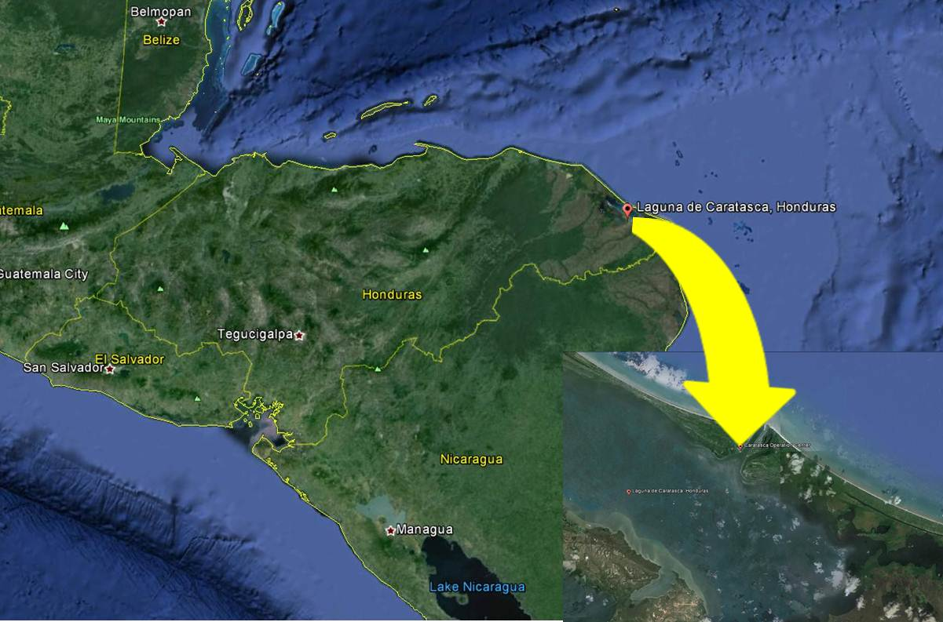

Figure #1

1.0 Introduction:

This Statement of Work (SOW) applies to the installation and interconnection of a new 50 KW Off-Grid hybrid renewable energy system at Caratasca, Honduras with the existing 10KW Hybrid system. The Contractor is responsible for providing all personnel, permits, equipment, parts and services under the terms of this contract.

1.1 Scope:

The Contractor shall furnish all labor, permits, transportation, equipment, materials, and any other items necessary for the installation of a complete and usable Off-Grid Hybrid system for the Operation Center at Caratasca, Honduras. Once the new 50KW system is in place and in operation, the contractor shall relocate and interconnect the existing 10KW Hybrid system inverters and electrical panels to the new 50KW Hybrid system.

All work shall be in conformance with all applicable referenced criteria, construction standards, laws and regulations, including applicable building, fire, life, and safety codes. Only new materials and equipment shall be installed in the work, and shall be of commercial or industrial grade and UL Listed. No obsolete or discontinued materials, equipment, and/or appliances shall be used. .

1.2 Base Bid:

- Provide all labor and material to install a complete and usable 50KW-Hrs Off-Grid Hybrid system. The Hybrid system shall consist of:

- Two 5 KW Vertical Axis Wind Turbine for a total of 10KW. Each turbine shall have its own inverter system and hurricane rated tie-downs.
- One 40 KW solar photovoltaic system
- One battery bank suitable for 1 day of autonomy

- The Contractor shall supply all necessary equipment and material (such as and not limited to: panels, Vertical Axis Wind Turbine VAWT’s, anchor system, inverters, combiner boxes, fuse boxes, controller, wiring, and ground mounted racks) in order to provide a complete and fully functional system.

1.2.1 Bid Options:

A. Bid Option # 1: Furnish all labor, transportation, equipment, materials, and any other items necessary for the installation of an additional 5 KW solar photovoltaic system to the Base bid.

B. Bid Option # 2: Furnish all labor, transportation, equipment, materials, and any other items necessary for the installation of an additional 5KW Vertical Axis Wind Turbine. Turbine shall have its own inverter.

C. Bid Option # 3: Furnish all labor, transportation, equipment, materials, and any other items necessary to increase the battery bank capacity for a total of two (2) days of autonomy.

1.3 Place of Performance: Caratasca, Honduras
- Caratasca is located off the coast of Honduras
- Grid coordinates for Caratasca Operation Center are:
15⁰ 22’ 32.8” N, 83⁰ 44’ 24.58” W
- The current voltage is 110/220 volts 60 Hz.

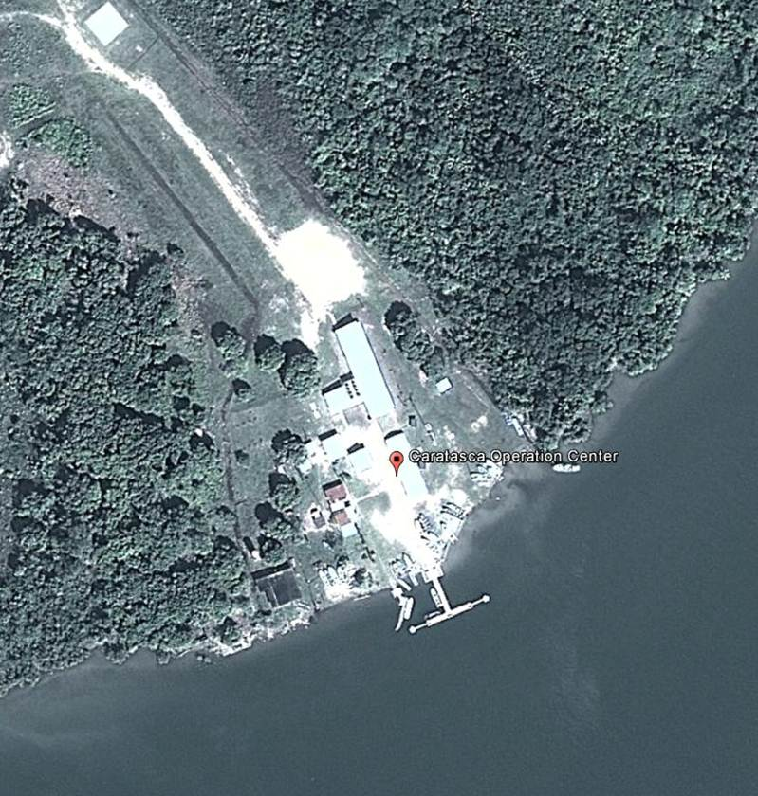

Figure # 2

1.4 Period of Performance:

Contractor performance time is based on calendar days and shall not exceed 200 calendar days from the issuance of the notice to proceed (NTP). Contractor shall have all materials on-hand prior to mobilizing but no later than (NLT) 10 days of NTP. Workday losses due to inclement weather shall be extended on a day for day basis with no monetary compensation. Workday losses for inclement weather are those days which 50% or more of the day is lost and shall be submitted for approval to the Contracting Officer (KO) or Project Engineer. The Contractor shall maintain a daily log for weather and personnel on site. The KO in his or her capacity shall conduct inspections and review of such documents during and upon completion of the project.

2.0 Specifications:

2.1 Solar Panel Equipment Specifications: 200 watt module (minimum)

*Note: variations in temperature and irradiance from standard test conditions affect module output and must be addressed and considered in system design.

- Performance under standard test conditions
    - Maximum power Pmax: 200w (minimum)
    - Open circuit voltage Voc: 44.4V
    - Maximum power point voltage Vmpp: 35.7
    - Short circuit current Isc: 5.4
    - Maximum power point current I mpp: 4.9
    - Classification: UL 1703 listed

- Performance under standard test conditions (minimum)
  - Cells per module: 72
  - Solar Cells: poly-crystalline silicon

- Rated Power and maximum tolerance
  - Rated power: 200 Wp +/- 3% (minimum)
  - Connecting socket: IP 65
  - Plug: MC type 4

- Thermal Characteristics
  - NOCT: 46°C
  - TK Isc: 0.06% /K
  - TK Voc: -.35%/K

- Approved Manufactures (Products must be from these manufacturers or equal).
  - B P Solar Int'l LLC
  - Evergreen Solar Inc
  - GE Energy (USA) LLC
  - Kyocera Solar Inc
  - Mitsubishi Electric & Electronics USA, Inc
  - Pacific SolarTech
  - SANYO Energy (USA) Corporation
  - Sharp Manufacturing Company of America
  - Sunwize Technologies LLC
  - United Solar Ovonic LLC.
  - Ironridge

- Warranty: 20 Years
  - Minimum Safety Ratings & Warranties Fire Safety Classification Class C Certifications UL 1703, CEC, IEC61215, IEC61730.

  - Warranty 5 years limited product warranty.

  - Performance guarantee:
- 10 years limited warranty of 90% power output.
- 25 years limited warranty of 80% power output.

- Junction Box
(1) General
- 600 Vdc Rated
- 10 to 20 circuits (suitable to handle the load)
- 1-20 Amp fuses (suitable to handle the load)
- ETL Listed to UL 1741. NEMA 3R enclosure

- Ground Fault Protector
(1) General
- Heavy Duty Non Fusible Safety Switch
- Number of Poles: 3
- Single Throw, 3 Wire, 3 Blades
- Maximum Current Rating 30 Amps
- NEMA Class 3R Rainproof
- Power Rating: 15 HP
- Maximum Power: 20 HP
- AC Voltage 208-220/480 Volts, Three Phase
- Red and Black Handle to Indicate Switch Position

- DC Fused Switch
(1) Suitable to handle maximum operating loads.

- Inverter (For reference only)
(1) General
- Certified to the new UL 1741/ IEEE 1547
- 600Vdc rated
- 10-year standard warranty
- Pre-wired at factory
- Integrated load-break rated DC disconnect switch
- CEC efficiency of up to 96 %
- Integrated fused series string combiner
- Sealed electronics enclosure and OptiCool
- Ideal for commercial applications
- Die Cast Aluminum (NEMA3R)

(2) Input Data
- Recommended maximum PV Power (Module @ STC): Required for System
- Max. DC Voltage: 600V
- Peak Power Tracking Voltage: 250V-480V
- DC Max. Input Current: 180 amps
- DC Voltage Ripple: < 5%
- Number of Fused String Inputs : 25 x 15 amps (AC/DC disconnect)
- PV Start Voltage (adjustable): 300 volts

(3) Output Data
      - AC Nominal Power: Required for system operation.
      - AC Maximum Output Power: Required for system for system operation.
      - AC Maximum Output Current: 117A, 101A, 51A
(per phase @ 208, 240, 277 V)
      - AC Nominal Voltage / Range (3-Phase):
          - 183-229V @ 208V
          - 211-264V @ 240V
          - 244-305V @ 277V
      - AC Frequency / Range: 60Hz
      - Power Factor: .99
      - Peak Inverter Efficiency: 97.1%
      - CEC Weighted Efficiency: 95.5% @ 208V 96 % @ 240V, 277V
      - Warranty: 10 years

- Approved Inverter Manufacturers
  - Exeltech
  - Heart Interface/Xantrex
  - Magnum Energy
  - OutBack Power
  - Prosine
  - Samlex
  - SMA
  - Xantrex
  - Sunny Island

- Inverter Location: Due to the climate conditions of the geographic location, all inverters shall be installed on the second floor of the Maintenance building/utility room

- Ground Mounted Racks
(1) General:
- Panel supports system shall conform to local building codes for loads in particular wind loads of 150 mph.
- Aluminum structural components and stainless steel hardware.
- Design Wind Pressure: 30 to 50 psf.
- No wood structure will be allowed.

(2) All components of the rack system shall consist of:
- Mill finished extruded aluminum alloys: 6005-T5, 6105-T5, 6061-T6
- Ultimate Tensile: 38ksi, Yield: 35 ksi

(3) Approved Manufacturers of the rack systems (Equal or better).
- Use of a manufactured and engineered ground mounted rack system is required.
- Unirac-rack system manufacturer

- Watt Hour Meter.
(1) General:
- Contractor shall provide one digital Watt hour meters to measure power generated for the entire Hybrid System.

2.2 Wind Turbine Specifications
- Only Magnetic Vertical Axis Wind Turbine (VAWT) will be considered.
- Physical Data (for reference only)
- Sail Dimensions: 8’h x 14’d
- Generator Dimensions: 24.5’h x 40’ d (44’d base plate)
- Assembled Dimensions: 130.5’h x 168’d
- Sail Weight: 538 lbs
- Generator Weight: 1383 lbs
- Assembled Weight: 1921
- Maximum Side Load: 672 lbs
- Maximum Torque: 4424 lbs
- Each turbine shall have its own inverter and properly sized for its use.

- Operational Data (for reference only)
- Rated Output: 5000 watts
- Maximum Output: 6000 watts
- Start-up Wind Speed: 1-2 mph
- Cut-in Wind Speed: 4 mph
- Cut-out Wind Speed: 120 mph
- Rated Temperature Range: -45F to 140F
- Over Speed Protection: Electromagnetic Brake
- Generator: Permanent Magnet
- Noise Level: <50dB
- Manufacturer Warranty: min 10 years.
- Approved Vertical Axis Wind Turbine Solar Manufacturers.
- Helix Wind
- PacWind Vertical Axis Wind Turbine
- Enviro Energies
- V.A.W.T Industries
- Green Energy Solutions
- Aeolos
- Turbine supports (mast) system shall conform to local building codes for loads:
    - Wind loads of 150 mph.

- Aluminum structural components or hot galvanized steel (per ASTM 123) can be used to build the ground mounted racks.

- Design Wind Pressure 30 to 50 psf.
- Bid only VAWT with mast placed in concrete anchorage foundation. Provide anchorage details specified or recommended by manufacturer. Roof top systems will not be considered.
- Mast height shall be 30-40 feet.
- Value Engineering. None.
- Include guide wire tie-down system.
- Galvanized turn buckles & eye bolts.
- Kevlar braided wire

2.3 Batteries
- Requirements: The contractor shall provide enough deep cycle batteries in order to have 1 day of autonomy in case the Hybrid system fails. Contractor to provide battery calculations for review and approval with initial proposal. Contractor must supply all battery cables, lug connections, battery charge monitor, and one battery tester.

- Specifications:
    - Type: Absorbed Glass Mat (AGM)
    - Deep Cycle
    - Discharge Limit: 50%
    - Battery AH Capacity (@20 hour rate): 2000 minimum
    - Battery voltage: 2 volts
    - Warranty: 5 years

(3) Approved Deep Cycle Manufacturer (Products must be from these manufacturers or equal).
    - US Battery
    - Trojan Battery
    - Concorde Battery
    - Exide
    - Optima
    - Dyno Battery Inc

(4) Battery Racks
- Seismic Zone 4 rated
- Coated with acid-resisting baked enamel
- Adjustable rails
- Inter-battery cabling provided
- Battery bank to inverter load cabling
- Junction boxes & Bus bar assembly
- Custom Spill containment systems
- Independent grounding system.
      - Exhaust discharge system

(5) Battery Shed:
    - Contractor shall construct or provide a Battery Room storage shed (see figure #4 for reference)
    - Shed shall have minimum internal dimensions of
Length: 25 ft
Width: 7.5 ft
Height: 7.5 ft
Door Opening: 7.5 ft high & 3.5 ft wide
    - Weather Resistant (epoxy coated)
    - Water Proof
    - Battery shed shall have an independent roof mounted 1.5 KW system (solar panel with deep cycle battery back) to power internal lights and an exhaust fan
    - Exhaust fan shall provide at least 15 Air Changes per Hour (ACH). For the shed mentioned above (25ft x 7.5ft X 7.5ft) an exhaust fan of 400cfm will be required.
    - Independent grounding system. sol
    - Installed over 10 concrete pedestal of at least 3 feet high
    - Hurricane tide down straps
    - Storm Resistant Hurricane Louver with bird screen (aluminum mesh)
      - Class A (99%) effectiveness rating
      - Fabricated from 6063-T6 aluminum alloy
      - Blade to be minimum 0.060 thick extrusion
      - Frames to be minimum 0.080 thick
      - Dimension 4’ x 4’. Free area 7.24 sq. ft.
      - All louvers shall be furnished with C/S Powder Coat (1.5 to 3 mil thick
      - 20-year limited warranty against failure or excessive fading

- System Connection
    - The electrical Main Distribution Panel (MDP), all electrical sub-panels, batteries, and inverters shall be installed in the Battery Shed
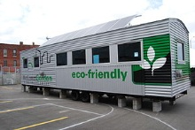
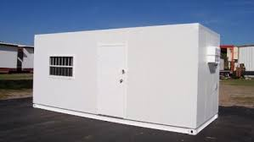

Figure # 4

2.4 Monitoring Equipment:
- Contractor shall provide a remote monitoring system to be installed at the Operations building (see figure # 5).

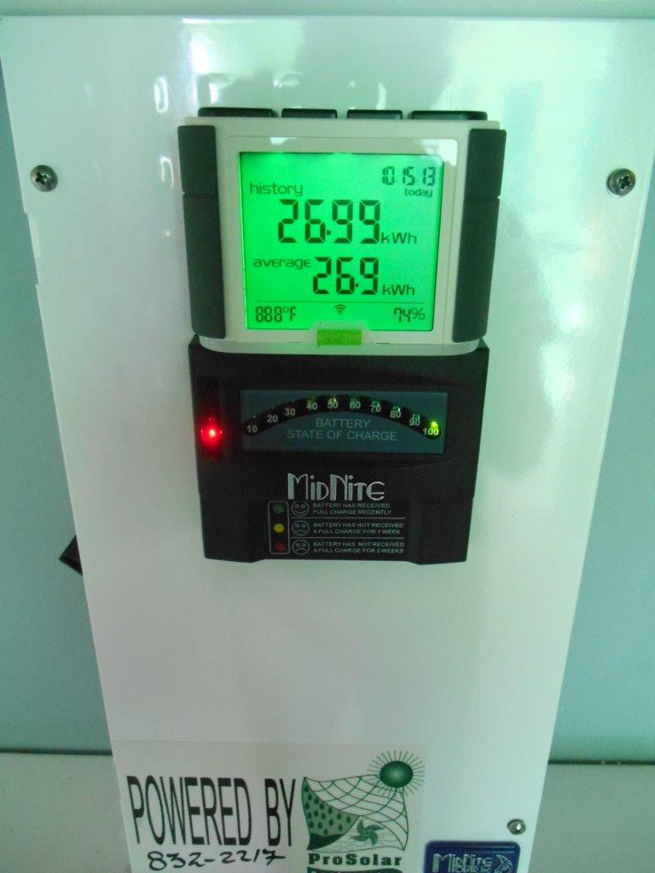

Figure # 5

- The monitoring system shall monitor the following:
      - Power produced by renewable energy system
      - Power consumed by facility
      - Battery bank status
      - Shall provide an audible alarm when power consumed is within 10% of power generated
      - Automatic shut off within 5% of Maximum power output with automatic shut-off switch.

- Additional Requirements
- Corrosion Protection. Contractor shall request all mechanical or electrical components exposed to the corrosive environment (including solar panels, inverters, rack, etc) to have corrosion protection.
- Contractor shall request their equipment supplier to provide mechanical or electrical supplies or materials to be factory coated.

2.5 Work Sequence:

- Contractor shall install the new 50KW the Off-Grid Hybrid system

- Once the new 50KW Hybrid System is operational, the contractor shall relocate the exisitng 10KW Hybrid electircal distribution panel, inverters , and other related equipment to the Battery Shed. The exisitng deep cycle batteries shall be removed from the site.
Bldg 930 Power Supply
3.0 Other Contract Requirements:

3.1 The Contractor shall be responsible for the professional quality, technical accuracy, and the coordination of all trades, designs, drawings, and specifications, furnished by the Contractor under this contract. Contractor is also responsible for modifying and validating designs provided by Government to consider current site conditions (i.e. soil conditions, elevation/topography, and utilities).

3.2 All the work shall be accomplished in accordance with local Government, and industrial codes, design and construction standards, rules and local frame works. If the local Government does not have industry standards, codes, designs etc., in place, the Contractor shall use U.S. industry standards. Should any conflict arise among them, the strictest of all the above shall be applied, and the Contractor shall inform the U.S SOUTHERN Command Engineer assigned to the project. The name of the U.S SOUTHERN Command project engineer shall be provided at the pre-construction conference to the successful Offeror.

3.3 Quality Control. The Contractor shall submit for review a Quality Assurance Plan (QAP) to the Contracting Officer within 10 days of the date of the contract award. The plan shall include the contractor’s process for managing performance in a safe, efficient, and timely manner, and a plan for mitigating and correcting any deficiencies that may arise. The level of surveillance will be established by the COR to give the Government the necessary assurance that the requirements of the Statement of Work are being met and that a process exists and is in place to ensure quality. If during the course of surveillance, the COR discovers the Contractor is not complying with the established level of quality performance, the level of surveillance may be increased.

3.4 Quality Assurance. The Government will conduct quality surveillance via various methods including formal and informal meetings, review of technical reports, review of Bi-Weekly Reports, and review of other submittals identified in paragraph 1.15 of this SOW. Contractor performance will be evaluated in the areas of performance (technical quality), schedule, and cost.

3.1 Applicable codes and standards:

The design and construction shall be in accordance with established construction practices, and the latest revision/edition of the following referenced codes and standards, where applicable. UFC 1-300-09N, Design Procedures, provides design guidance and contains references to other UFC’s and Codes that are to be used for this contract. UFC 1-200-1, General Building Requirements, is the building code guide and contains references to other UFC’s and Codes that are to be used in this contract.

- National Electrical Manufacturers Association (NEMA)
- Electronic Industries Alliance (EIA)
- Federal, State, County, and local environmental regulations.
- American Society of Testing and Materials (ASTM)
- National Fire Protection Association (NFPA) Codes and Standards
- IEEE C2, National Electrical Safety Code
- National Electrical Code 2011(NEC)

Where discrepancies in the referenced standards and the contract requirements occur, the most stringent requirements shall govern.

3.2 Designs/Drawings:

- The manufactured ground mount racks shall be designed and built according to the latest Seismic Resistant Code (NSR-98) and wind pressured specified to handle standard wind shear. The acceptance of the drawings by U.S. Southern Command does not waive the responsibility of the Contractor to comply with the corresponding codes and rules for the design and construction. The Contractor shall submit the construction designs/drawings based on the codes, signed and certified by a licensed structural engineer ten (10) days after contract award. The U.S. SOUTHERN Command engineer shall approve the design. Neither the U.S. Government’s review, approval or acceptance of, nor payment for the requirement required under this contract shall be construed to operate as a waiver of any rights under this contract or of any cause of actions arising out of the performance of this contract, and the Contractor shall be and remain liable to the U.S. Government in accordance with applicable law for all damages to the U.S. Government caused by the Contractor’s negligent performance under this contract.

- Once the design is approved, any design changes shall be submitted to the U.S. Southern Command Engineer for recommendation of approval. The Contracting Officer (KO) has final approval of all changes. Contractor shall not proceed without prior approval from the KO.

4.0 Deliverables after Award:

- Project Manager Contact Information: The Contractor shall provide to the Contracting Officer (KO) and the Project Engineer a phone number for the Project Manager and alternate(s) during duty and non-duty hours (evenings, holidays, and weekends) at 5 days prior to the commencement of work.

- Project Schedule: The Contractor shall submit to the project engineer a detailed project schedule ten (10) days (10) after award.

- Personnel Listing. After award of the contract, the Contractor shall have 5 days to submit to the Contracting Officer (KO) and the Project Engineer a list of workers and supervisors assigned to this project.

5.0 Technical Parameters:

- Prior to commencement of work, the Contractor shall conduct an on-the-ground site inspection of the surrounding area for any embedded obstructions or interferences to avoid any damage to any existing structures. The inspection shall include but not be limited to infrastructure, electrical poles and wiring, standing structures, trees, sewage/water pipes, or water wells, or any other obstructions. If the excavation interferes with sewage systems or pipes, the Contractor shall provide adequate protection for such structures.

- The Contractor shall maintain free access to siphons, lids, and collectors of public utilities networks to avoid any obstruction or damage.

- All debris generated in this project is the property of the contractor and is to be disposed of in a manner that is consistent with Government requirements. Construction related refuse must be disposed of in a Contractor provided container.

6.0 Personnel:

    - The Contractor shall provide a sufficient number of properly trained and qualified personnel to perform the requirements of this contract in the specified time.

    - Project Manager/Superintendent: The Contractor shall provide a Project Manager/Superintendent who shall be responsible for the performance of the work. The name of this person and an alternate(s) who shall act for the Contractor when the Project Manager is absent shall be designated in writing to the Contracting Officer (KO). The Contractor shall not replace, substitute, or remove key personnel without prior submission and approval by the Contracting Officer (KO). In the event the Contractor must remove key personnel, the Contractor shall replace the key personnel with equally or better qualified key personnel to replace previously approved key personnel. The Contractor shall provide to the Contracting Officer (KO) and the Project Engineer a phone number for the Project Manager and alternate(s) during duty and non-duty hours (to include evenings, holidays, and weekends) at least 5 days prior to the commencement of work.

    - The Project Manager or alternate(s) shall be physically present on site between the hours of 7:30 am to 4:30 pm, Monday through Friday, excluding U.S. Federal holidays or local holidays. This individual shall be responsible for overall management and coordination of this contract. This individual shall be responsible for directing the onsite work, acquiring materials, and be able to resolve construction issues and provide information about work progress to the Project Engineer. The Project Manager shall be knowledgeable of the project progress. This person shall be bi-lingual and speak English and Spanish.

7.0 Project Documents:

- The Contractor shall submit to the project engineer another detailed project schedule ten days (10) after award. The project schedule shall be complete with sufficient float time incorporated in the schedule to account for down days due to inclement weather. Contractor shall include quality assurance inspections at the critical milestones of the project and Activity Hazard Analysis (applicable to all types of work to be performed) that is to be held in advance of any special features of work such as site preparation, concrete work. The project schedule shall have expected completion dates, execution time of each phase, mid-point completion of project and monetary values.

- Contractor Records/Reports: The Contractor shall certify all completed work on a weekly basis. The Contractor shall provide biweekly progress reports with photographs to the Contracting Officer (KO) and the Project Engineer. Biweekly reports are due every Tuesday not later than 1300 hrs (1:00 pm CST).

- As-Builds. The Contractor shall submit 100 percent “As-Builds” construction designs/drawings based on the codes, signed and certified by a licensed civil engineer or architect thirty (30) days after completion of project. Drawings shall be submitted in electronic format CD ROM in AUTOCAD 2009 and B size on 11” X 17” plan sheets. Minimum drawing scale on each floor plan shall be 1/8” = 1’-0” and on each partial floor plan or detail shall be 1/4” = 1’-0” unless otherwise directed by the Contracting Officer. The preliminary as-built shall be submitted concurrently with the request for pre-final inspection.

- Training Videos. The contractor shall create two (each) videos that will be utilized for personnel training and continuity. The first video will be used as an Operational and Maintenance fundamentals video; provide a high quality video that will be filmed and narrated on site and be specific to Caratasca 50KW hybrid system. All critical site components shall be identified and described from the solar panels to the grid connection at the transformer. The majority of this video shall focus on the integrated inverters; operator interface screen; data logging; disconnects and fuses. Time shall be given to the general PV wire and panel maintenance. The second video will be of high quality and include PV fundamentals (DC, AC, MPPT, inverters, disconnects wiring and grounding), safety considerations, maintenance and operation.

7.1 Meetings:

- The Contractor’s Project Manager may be required to meet at least weekly with the Project Engineer and KO during the duration of the contract. The Contractor shall be responsible for keeping minutes to these meetings. The written minutes of these meetings shall be signed by the Project Manager, Contracting Officer (KO) and Project Engineer. Should the Contractor not concur with the minutes, the Contractor shall so state any areas of non-concurrence in writing to the Contracting officer (KO) within seven calendar days of receipt of the signed minutes. Concurrence of written minutes takes effect upon the signature of all parties. The Contractor shall be responsible for writing, staffing and maintaining minutes of construction meetings. The minutes shall be provided 5 days after the meeting.

8.0 U.S. and Host Nation Laws and Regulations:

- Compliance: The Contractor shall, without additional expense to the U.S. Government, be responsible for complying with all laws, codes, ordinances, and regulations applicable to the performance of the work, including those of the host country, and with the lawful orders of any Governmental authority having jurisdiction. In the event of a conflict between the contract and such laws, regulations and orders, the Contractor shall promptly advise the Contracting Officer (KO) of the conflict and of the Contractor’s proposed course of action for resolution by the Contracting Officer (KO).

- Labor, Health and Safety Laws. The Contractor shall comply with all local labor laws, regulations, customs and practices pertaining to labor, safety, and similar matters, to the extent that such compliance is not inconsistent with the requirements of this contract. The Contractor quality control personnel shall train personnel to recognize fire and safety hazards. Personnel should be able to identify and report common hazards during their performance of their duties. Personnel shall report hazards to the supervisor and Project Manager immediately upon identification.

- Licenses and Permits: The Contractor shall, at no additional cost to the U.S. Government, obtain all licenses and permits required for performance of work and for complying with all applicable Host Nation laws, rules, and regulations as concerns the environment and prosecution of work.

- Environmental Protection: In order to present and provide for abatement and control of any environmental pollution arising from the activities in the performance of this contract, the Contractor shall comply with all applicable pollution control and abatement, and all applicable provisions of the Government Codes and regulations/laws.

- The action required by this section consists of furnishing all labor, materials, tools and equipment to perform all work required for the abatement and prevention of pollution during and as the result of construction operations under this contract. For the purpose of this specification, environmental pollution is defined as the presence of chemical, physical, or biological elements or agents which adversely affect human health or welfare; unfavorably alter ecological balances; detrimentally impact on biological species and/or their habitat; or degrade the aesthetic and recreational value of the area.

- The Contractor shall not pollute storm or sewer lines, or swales with fuels, oils, bitumen, calcium chloride, acid, construction wastes, or other harmful materials. It is the responsibility of the Contractor to investigate and comply with all applicable laws concerning pollution of river and streams. All work under this contract shall be performed in such a manner that objectionable conditions shall not be created in water runoff/streams through or adjacent to the project areas.

- Waste Material: Waste material is defined as any material for which no use or reuse is intended and which is to be discarded. Disposal of hazardous waste, containers or components thereof, shall be disposed of in a hazardous waste disposal site only; no other location shall be utilized for such disposal. Only hazardous waste sites which are permitted by the US Environmental Protection Agency (EPA), and/or the local Government shall be utilized for such disposal actions. Contractor shall coordinate with local environmental agencies for disposal/storage activities.

- Utilities Excavation and Connection: The U.S. Government shall not provide any utility connections. The Contractor is responsible for providing any needed generators to operate any equipment at its own expense. The Contractor is also responsible for providing potable water for his daily construction works and his employees at its own expenses. The Contractor is responsible for providing registration information for any potable water tank truck planned for the projects on site staff. The equipment shall form part of the equipment list. In addition, the Contractor is responsible for coordinating excavation with local utilities companies and department of public works and avoiding damage to underground utilities. Contractor is: (1) responsible for all damage to underground utilities and shall repair any damage done during construction; (2) responsible for coordinating the connection of potable water (if available), sewage (if available); and (3) electrical power with local utilities companies (if available).

9.0 Site Mobilization:

9.1 Responsibility of Contractor:

      - Damage to Persons or Property. The Contractor shall be responsible for all damages to persons or property that occur as a result of the Contractor's fault or negligence, and shall take proper safety and health precautions to protect the work, employees, local public, and the property of others.

      - Responsibility for Work Performed. The Contractor shall be responsible for all materials delivered, storage and care of such items and work performed until final completion and acceptance of the entire work except for previously accepted work.

      - Project Site Boundary and Fencing: The work zone shall be marked using two lines of plastic yellow security ribbon that shall be made visible to all work personnel and visitors. These ribbons shall be 8 cm wide and supported on very stable wood stakes or like items. The project high accident risk zones shall be signaled with warning signs and fencing as protection measurements.

      - Debris Removal: The Contractor shall remove all trash, debris, or surplus materials from the work site and shall leave the work site clean of all debris when work is completed. The Contractor shall maintain the work site in a neat, orderly, and safe condition at all times. The Contractor shall remove trash and debris on a daily basis.

      - The Contractor (with local Government agencies permits) shall dispose of materials in their landfills or designated areas.

      - The Contractor shall maintain project site cleanliness at all times.

9.2 Construction Operations and Storage Areas:

  - Confinement to Authorized Areas. The Contractor shall confine all operations (including storage of materials) to the designated premises approved by the Contracting Officer (KO). U.S. Government agencies shall have access to the premises for official fire, safety, and security inspections and/or to conduct site visits as authorized by the Contracting Officer (KO).

  - Contractor Storage/Lay down Area. The Contractor shall only store materials and equipment for this project at the designated project site. A specific site/location shall be coordinated with the KO or COR and local stakeholders during the Pre-performance conference.

9.3 Contractor Vehicles:

- Vehicular Access. The Contractor shall, and in accordance with any regulations prescribed by the Contracting Officer (KO), use only established site entrances and roadways.

- The Contractor shall provide a list of all vehicles used in the performance of this contract to include vehicle description, valid vehicle registration number, and Identification ID card numbers to the to the Contractor officer, and Project Engineer five days after contract award and update as the changes occur. This information shall be used by the installation to verify credentials and issue access permits.

9.4 Personnel:

- The Contractor shall provide a sufficient number of properly trained and qualified personnel to perform the requirements of this contract.

- Subcontractors: The Contractor shall give written assurance to the Contracting Officer (KO) that all Subcontractors and others performing work on or for the project have obtained all requisite licenses and permits. The Contractor shall submit proper documentation and evidence satisfactory to the Contracting Officer (KO) demonstrating compliance with this paragraph when directed by the Contracting Officer (KO). The Contractor is responsible for all actions and work provide by any sub contractor.

- Personnel Safety and Equipment: The Contractor is responsible for the safety of workers and visitors to the work site. The Contractor shall immediately correct all safety deficiencies upon notification of the deficiencies by the Contracting Officer (KO) or Project Engineer, and shall notify the Contracting Officer (KO) or Project Engineer of the corrective action to be taken. The Contractor shall ensure that all personnel are wearing appropriate safety equipment, i.e.: hard hat, safety glasses, protective clothing at all times. The Contractor shall provide each employee a shirt with the Contractor’s name/logo. The shirt shall be worn at all times while working in the installation. The shirts shall be the same color and style for ease of Contractor identification.

- Accident Protection (AP) and Emergency Medical Treatment (EMT). Contractor shall ensure all work is performed in accordance with internal safety standing operating procedures and that the Contractor has emergency medical procedures in place to save life or limb of personnel on the job site. The Contractor shall have competent personnel trained and capable of dealing with minor personnel injuries. Contractor shall be responsible to provide AP and EMT to its employees. All work crews, office personnel, and the COR shall be provided with information pertaining to the Contractor's arrangements for emergency medical treatment prior to contract start date.

10.0 Unforeseen repairs beyond the scope of the contract:

- The Contractor shall notify the Contracting Officer and COR within 24 hours if there are any issues that need attention or could otherwise delay the project.

- Should deteriorated material of a major nature be uncovered in the course of the work, it shall be brought to the attention of the Contracting Officer immediately. All repairs shall be made only as directed in writing, by the Contracting Officer. Any additional work that may increase the original cost of this contract must be approved by the KO and funded prior to execution.

11.0 Availability of utilities:

  - None available at this time. Contactor shall supply its own power and water.

11.1 Interruption of utilities services (if applicable)

  - Planned interruptions of utility services (electrical power, water, natural gas, sanitary, sewer, telephone, etc.) shall be detailed and coordinated by the Contractor. If the outage affects only the facility in this contract, the Contractor shall submit the request at least five (5) working days before the planned outage. The Contractor shall not interrupt service(s) until written approval has been granted. Requests shall include facility/facilities affected, date of scheduled outage, and duration. Requests for interruption of service(s) shall not be approved until all equipment and materials required for that particular phase of work are on the job site.

12.0 Drug abuse by contract employees:

- It has been determined that the illegal possession and use of drugs and paraphernalia by civilian and contract employees in the Government setting contributes directly to widespread military drug abuse and undermines command efforts to eliminate drug abuse among military personnel. Every effort will be made to deter and detect drug offenses by civilian and contract employees on military installations.

- Measures to be taken to identify drug offenses and paraphernalia include routine, random inspection of vehicles on entry and exit, with drug detection dog teams, when available; and random inspection of personal possessions on entry or exit.

- Where there is probable cause to believe that civilian or contract personnel on a military installation has been engaged in use, possession or trafficking of drugs, that employee may be restricted or detained for the period necessary until the employee can be removed from the installation or can be turned over to local Law Enforcement authorities having jurisdiction, when appropriate. In any event, civilian or contract employees suspected of committing a drug offense on the Government installation may be removed at the earliest opportunity.

- When illegal drugs are discovered in the course of an inspection or search of a vehicle operated by a civilian or contract employee, the employee and the vehicle may be detained for a reasonable period of time necessary to turn the employee and the vehicle over to appropriate civil law enforcement officials, and action may be taken to suspend, revoke or deny installation driving privileges.

13.0 Holidays:

- The Contractor shall not schedule work on U.S or Local Holidays, or the day of holiday observance. The Contractor shall notify the COR and installation point of contact, if planning to work during these days.

- U.S. Federal Holidays:

New Year’s Day 01 Jan 14
Martin Luther King, Jr. 20 Jan 14
Washington’s Birthday 17 Feb 14
Memorial Day 26 May 14
Independence Day 04 July 14
Labor Day 01 Sep 14
Columbus Day 13 Oct 14
Veterans Day 11 Nov 14
Thanksgiving Day 27 Nov 14
Christmas Day 25 Dec 14

- Local Holidays

New Year's Day 01 Jan 14
Three Wise Men day 06 Jan 14
Our Lady of Suyapa 02 Feb 14
Father’s Day 19 Mar 14
America Day 14 Apr 14
Maundy Thursday 17 Apr 14
Good Friday 18 Apr 14
Easter Day 20 Apr 14
Labor Day 01 May 14
Mother’s Day 11 May 14
Corpus Christi 19 Jun3 14
Independence Day 15 Sep 14
Teacher’s Day 17 Sep 14
Morazan’s Day 03 Oct 14
Columbus Day 12 Oct 14
Christmas Day 25 Dec 14
New Year’s Eve 31 Dec 14

Figure # 6

